SQL 튜닝 결과서

1. 대상 정보
항목 | 내용
시스템 | [DEV] RDS Aurora PostgreSQL 16.9 Database
DBMS | rds-esp-dev-aurora-postgresql-main-1
대상 SQL | /* com.ezwelesp.bo.hims.common.rest.cspcsinquiry.mapper.query.CspCsInquiryQueryMapper.getCspCsInquiryList_COUNT */  SELECT  count(0)  FROM  (  SELECT  *  FROM  EZ_CM.bb_csp_inq_b inq OFFSET 0  ) inq  LEFT JOIN ez_pd.pd_gds_c gds ON gds.gds_cd = inq.gds_cd  LEFT JOIN ez_dp.dp_std_ctgr_b ctgr ON gds.mng_std_ctgr_cd = ctgr.std_ctgr_cd  LEFT JOIN ez_cm.cm_mgr_md_b mgr_md ON ctgr.mgr_md_no = mgr_md.mgr_md_no  LEFT JOIN ez_co.co_csp_b csp ON inq.csp_cd = csp.csp_cd  LEFT JOIN ez_or.or_ord_b ord ON inq.ord_no = ord.ord_no  LEFT JOIN ez_voc.voc_comm voc2 ON LEFT(inq.csp_inq_typ_cval, 7) = voc2.voc_code  AND voc2.voc_gubn = 'TP_TYPE2'  LEFT OUTER JOIN LATERAL(  SELECT  usr_nm,  usr_id  FROM  ez_pi.pi_usr_pi_d cub  WHERE  ord.user_key = cub.user_key  UNION ALL  SELECT  usr_nm,  usr_id  FROM  ez_pp.pp_npa_usr_pi_d pp  WHERE  ord.user_key = pp.user_key  ) cub ON 1 = 1  WHERE  1 = 1
작성일 | 2026.05.18
작성자 | 최준연

2. 현상
항목 | 개선 전
증상 | 기준 테이블 협력사문의기본(bb_csp_inq_b)에 사용자개인정보상세(pi_usr_pi_d)와 경찰청사용자개인정보상세(pp_npa_usr_pi_d)로 불 필요한 OUTER JOIN 존재하고  상단에 의미 없는 인라인 뷰 (bb_csp_inq_b)로 인한 실행 성능 저하
평균 수행시간 | 42,596.32 (≃ 42초)
최대 수행시간 | 1,046,269.52 (≃ 17분)
호출 건수 | 7,401
실행계획 | QUERY PLAN  -------------------------------------------------------------------------------------------------------------------------------------  Aggregate (actual time=717153.836..717153.839 rows=1 loops=1)  Buffers: shared hit=1728175 read=295966  I/O Timings: shared read=806005.712  -> Nested Loop Left Join (actual time=0.068..717028.860 rows=177347 loops=1)  Buffers: shared hit=1728175 read=295966  I/O Timings: shared read=806005.712  -> Nested Loop Left Join (actual time=0.029..562506.214 rows=177347 loops=1)  Buffers: shared hit=420436 read=236585  I/O Timings: shared read=656165.858  -> Seq Scan on bb_csp_inq_b inq (actual time=0.007..1709.193 rows=177347 loops=1)  Buffers: shared hit=25469 read=3137  I/O Timings: shared read=99869.424  -> Memoize (actual time=3.161..3.161 rows=1 loops=177347)  Cache Key: inq.ord_no  Cache Mode: logical  Hits: 51662 Misses: 125685 Evictions: 60656 Overflows: 0 Memory Usage: 8193kB  Buffers: shared hit=394967 read=233448  I/O Timings: shared read=556296.434  -> Index Scan using or_ord_b_pk on or_ord_b ord (actual time=4.454..4.454 rows=1 loops=125685)  Index Cond: ((ord_no)::text = (inq.ord_no)::text)  Buffers: shared hit=394967 read=233448  I/O Timings: shared read=556296.434  -> Append (actual time=0.847..0.869 rows=1 loops=177347)  Buffers: shared hit=1307739 read=59381  I/O Timings: shared read=149839.854  -> Subquery Scan on "*SELECT* 1" (actual time=0.810..0.825 rows=1 loops=177347)  Buffers: shared hit=781171 read=56859  I/O Timings: shared read=143431.302  -> Index Only Scan using pi_usr_pi_d_pk on pi_usr_pi_d cub_1 (actual time=0.808..0.823 rows=1 loops=177347)  Index Cond: (user_key = (ord.user_key)::text)  Heap Fetches: 10386  Buffers: shared hit=781171 read=56859  I/O Timings: shared read=143431.302  -> Subquery Scan on "*SELECT* 2" (actual time=0.043..0.043 rows=0 loops=177347)  Buffers: shared hit=526568 read=2522  I/O Timings: shared read=6408.552  -> Index Only Scan using pp_npa_usr_pi_d_pk on pp_npa_usr_pi_d pp (actual time=0.041..0.041 rows=0 loops=177347)  Index Cond: (user_key = (ord.user_key)::text)  Heap Fetches: 27  Buffers: shared hit=526568 read=2522  I/O Timings: shared read=6408.552  Planning:  Buffers: shared hit=1446 read=20  I/O Timings: shared read=123.519  Planning Time: 128.418 ms  Execution Time: 717154.686 ms

3. 튜닝 전 SQL / 실행 결과

/* com.ezwelesp.bo.hims.common.rest.cspcsinquiry.mapper.query.CspCsInquiryQueryMapper.getCspCsInquiryList_COUNT */

explain (analyze, buffers, timing, costs off)

SELECT

count(0)

FROM

(

SELECT

*

FROM

EZ_CM.bb_csp_inq_b inq OFFSET 0

) inq

LEFT JOIN ez_pd.pd_gds_c gds ON gds.gds_cd = inq.gds_cd

LEFT JOIN ez_dp.dp_std_ctgr_b ctgr ON gds.mng_std_ctgr_cd = ctgr.std_ctgr_cd

LEFT JOIN ez_cm.cm_mgr_md_b mgr_md ON ctgr.mgr_md_no = mgr_md.mgr_md_no

LEFT JOIN ez_co.co_csp_b csp ON inq.csp_cd = csp.csp_cd

LEFT JOIN ez_or.or_ord_b ord ON inq.ord_no = ord.ord_no

LEFT JOIN ez_voc.voc_comm voc2 ON LEFT(inq.csp_inq_typ_cval, 7) = voc2.voc_code

AND voc2.voc_gubn = 'TP_TYPE2'

LEFT OUTER JOIN LATERAL(

SELECT

usr_nm,

usr_id

FROM

ez_pi.pi_usr_pi_d cub

WHERE

ord.user_key = cub.user_key

UNION ALL

SELECT

usr_nm,

usr_id

FROM

ez_pp.pp_npa_usr_pi_d pp

WHERE

ord.user_key = pp.user_key

) cub ON 1 = 1

WHERE

1 = 1

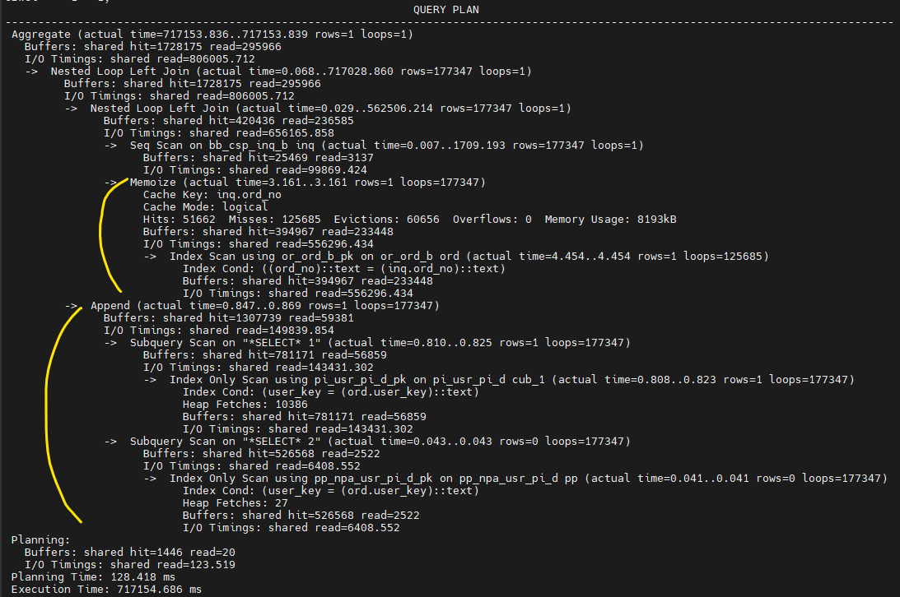불 필요한 OUTER JOIN인 Buffers: shared hit=1362650 read=2809 와 잘못 된 인라인 뷰인 Buffers: shared hit=596919 read=31496 발생

4. 튜닝 후 SQL / 실행 결과

/* com.ezwelesp.bo.hims.common.rest.cspcsinquiry.mapper.query.CspCsInquiryQueryMapper.getCspCsInquiryList_COUNT */

explain (analyze, buffers, timing, costs off)

SELECT

count(0)

FROM EZ_CM.bb_csp_inq_b inq

LEFT JOIN ez_pd.pd_gds_c gds ON gds.gds_cd = inq.gds_cd

LEFT JOIN ez_dp.dp_std_ctgr_b ctgr ON gds.mng_std_ctgr_cd = ctgr.std_ctgr_cd

LEFT JOIN ez_cm.cm_mgr_md_b mgr_md ON ctgr.mgr_md_no = mgr_md.mgr_md_no

LEFT JOIN ez_co.co_csp_b csp ON inq.csp_cd = csp.csp_cd

LEFT JOIN ez_or.or_ord_b ord ON inq.ord_no = ord.ord_no

LEFT JOIN ez_voc.voc_comm voc2 ON LEFT(inq.csp_inq_typ_cval, 7) = voc2.voc_code

AND voc2.voc_gubn = 'TP_TYPE2'

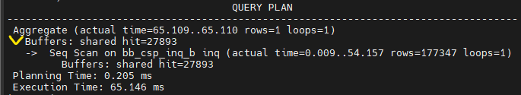Buffers: shared hit=27893 로 감소

5. 개선 내용
불필요한 OFFSET 포함 INLINE VIEW 제거 및 불필요한 OUTER JOIN 제거를 통해 SQL 단순화 및 COUNT 실행계획을 최소화하고 SQL 처리 비용 최적화함

SQL / 인덱스 개선
- SQL개선
- 인덱스 개선
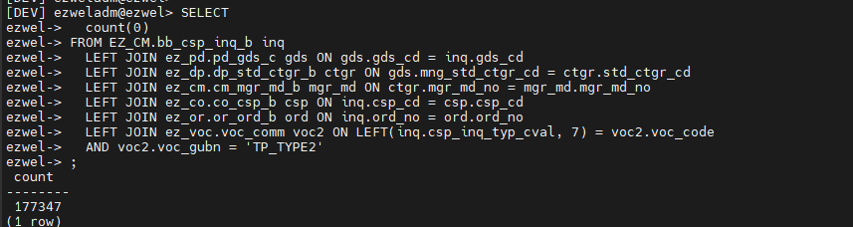
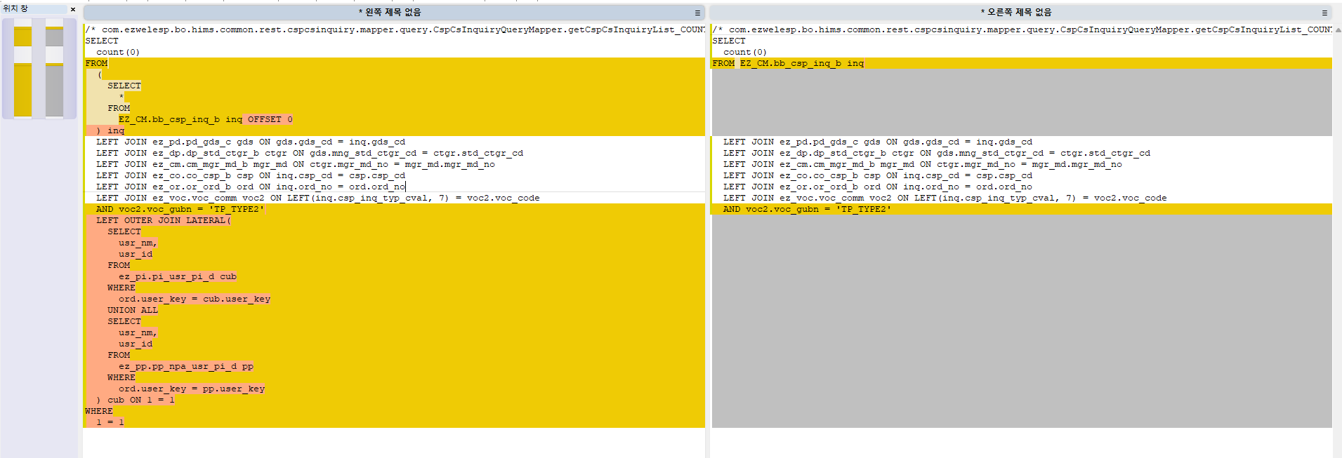

통계 갱신 (Optional)
- 통계 갱신 여부

튜닝 결과
튜닝 전 해당 SQL의 최대 실행 시간이 약 20분에서 튜닝 후 0.06초로 개선 됨
총 액세스 block 수는 1,987,459에서 27,893로 감소, Disk Read 수가 34,308에서 0으로 대폭 감소

항목 | 개선 전 | 개선 후
튜닝 실행 시간 | Execution Time: 82320.463 ms | Execution Time: 67.310 ms
최대 실행시간 | max_exec_time : 1196781.068519 ms | max_exec_time : 67.310 ms
평균 실행시간 | mean_exec_time : 423175.43831236666 ms | mean_exec_time : 67.310 ms
디스크 읽기 블럭 수 | 34308 | 0
총 액세스 블럭 수 | Buffers: shared hit=1987459 read=34308 | Buffers: shared hit=27893

